**Group A**

**Lab 3A**

**Scala**

**Participants:**

**1. Aadarsha chapagain**

**2.Jyoti shukla**

**3.Rishi Phaneendra Varma**

**4.Priti Bhale**

**5.Sreya Treesa Johny**

**6.Piyush Bhatia**

**Slide 35:**

While(x>=1){

println(“Hello”)

x=-1

}

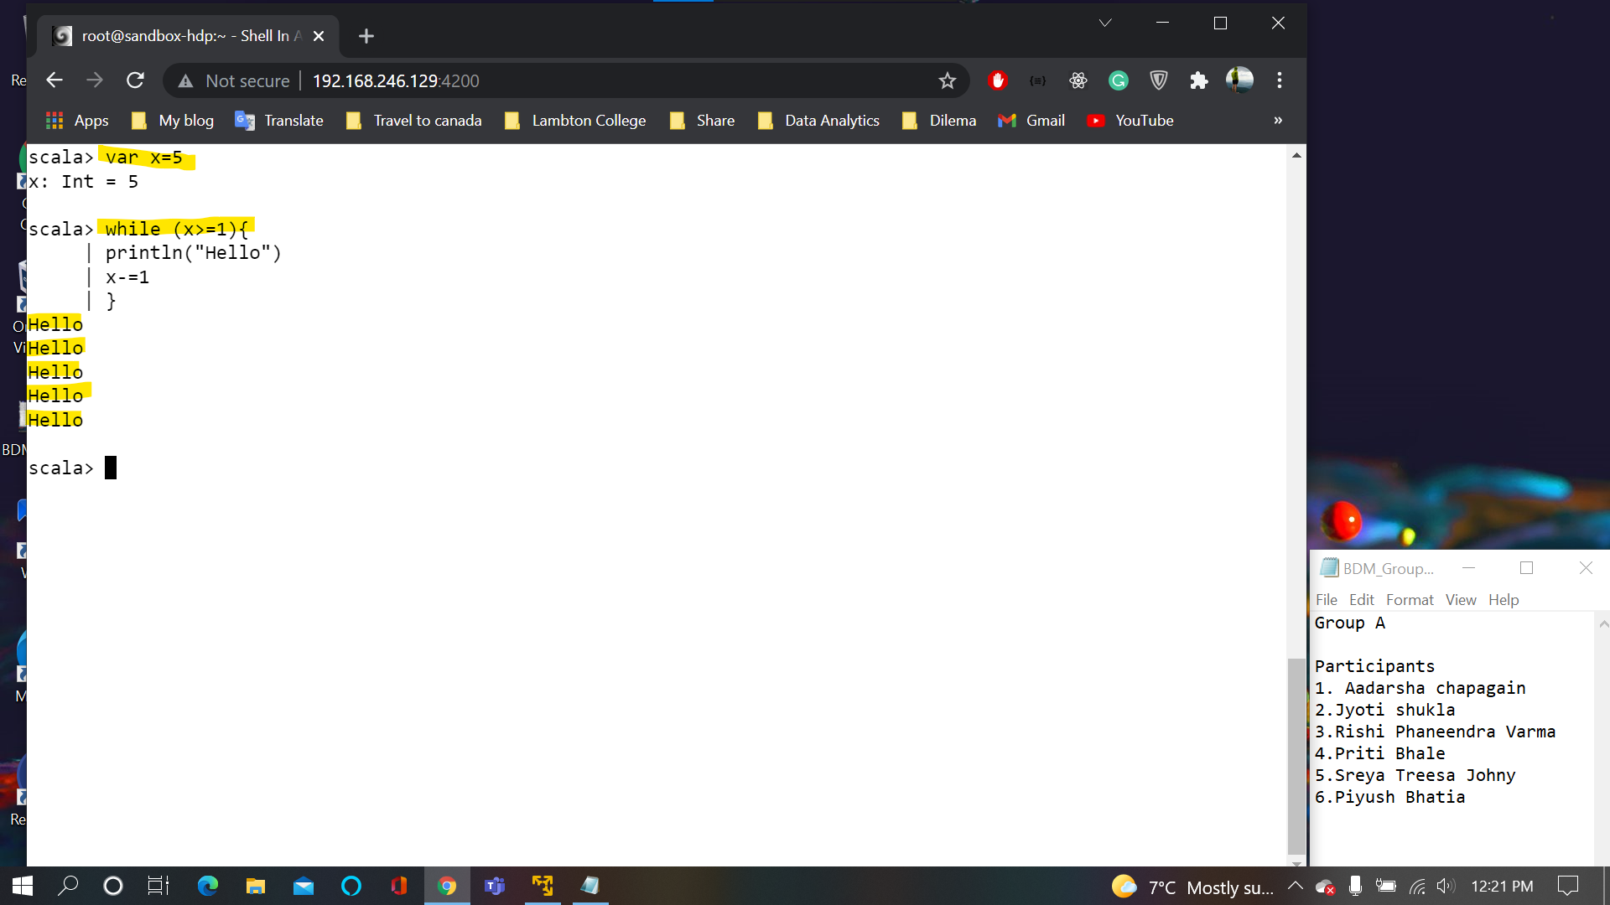

**Slide 36:**

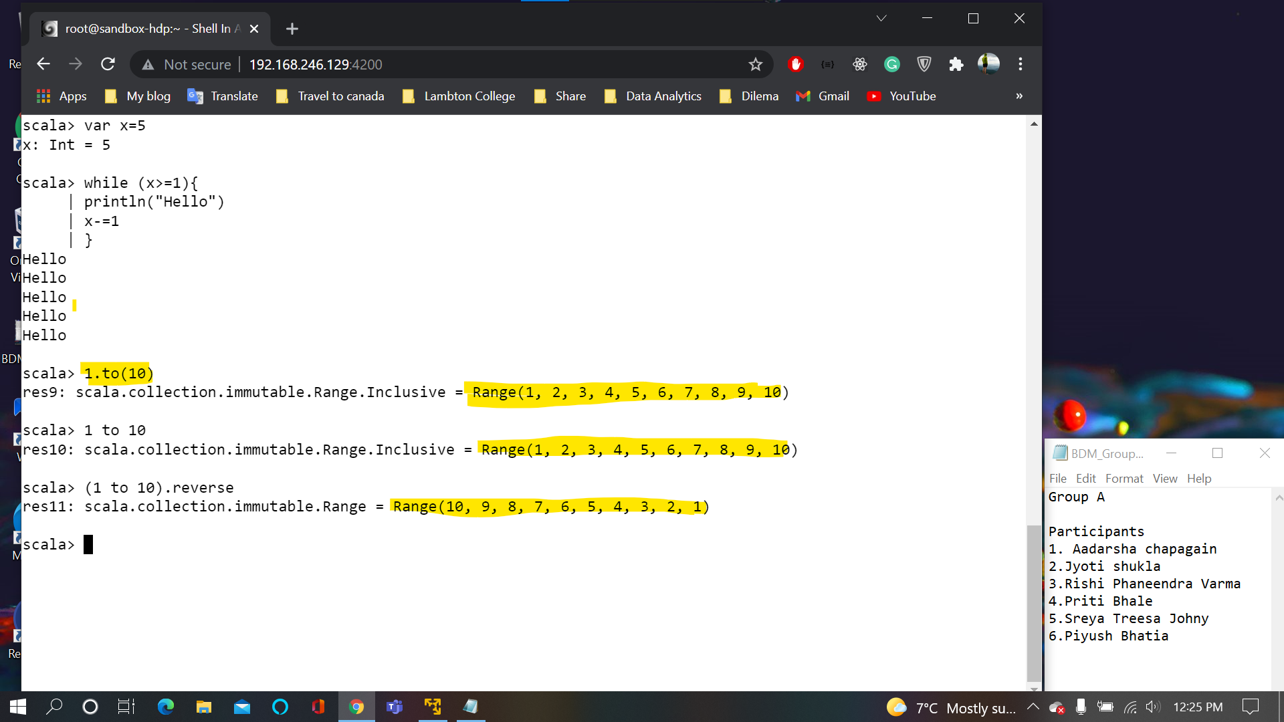

**Slide 37:**

for(i<-1 to 10)println(i)

for(i<-(1 to 10).reverse)println(i)

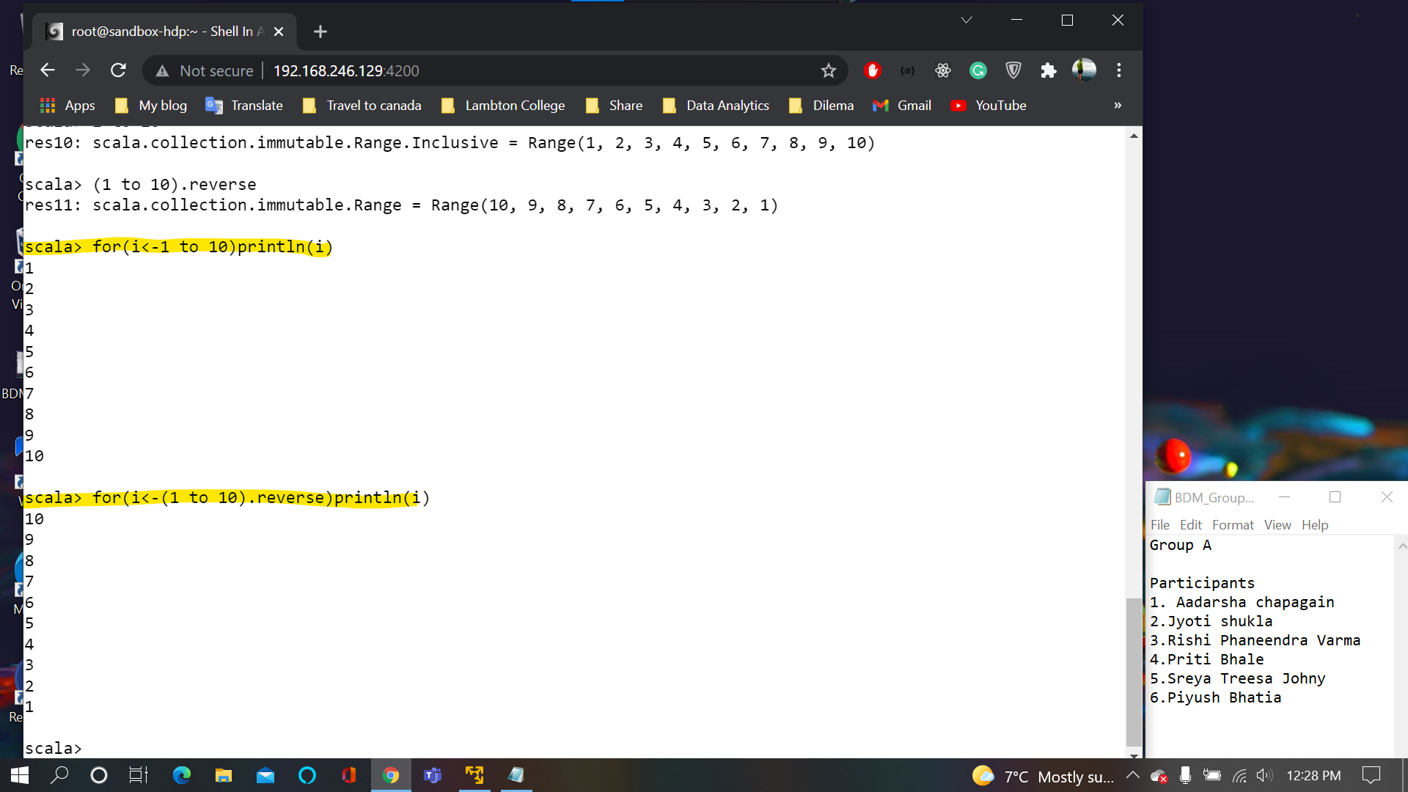

**Slide 38:**

for(i<-1 until 10)println(i)

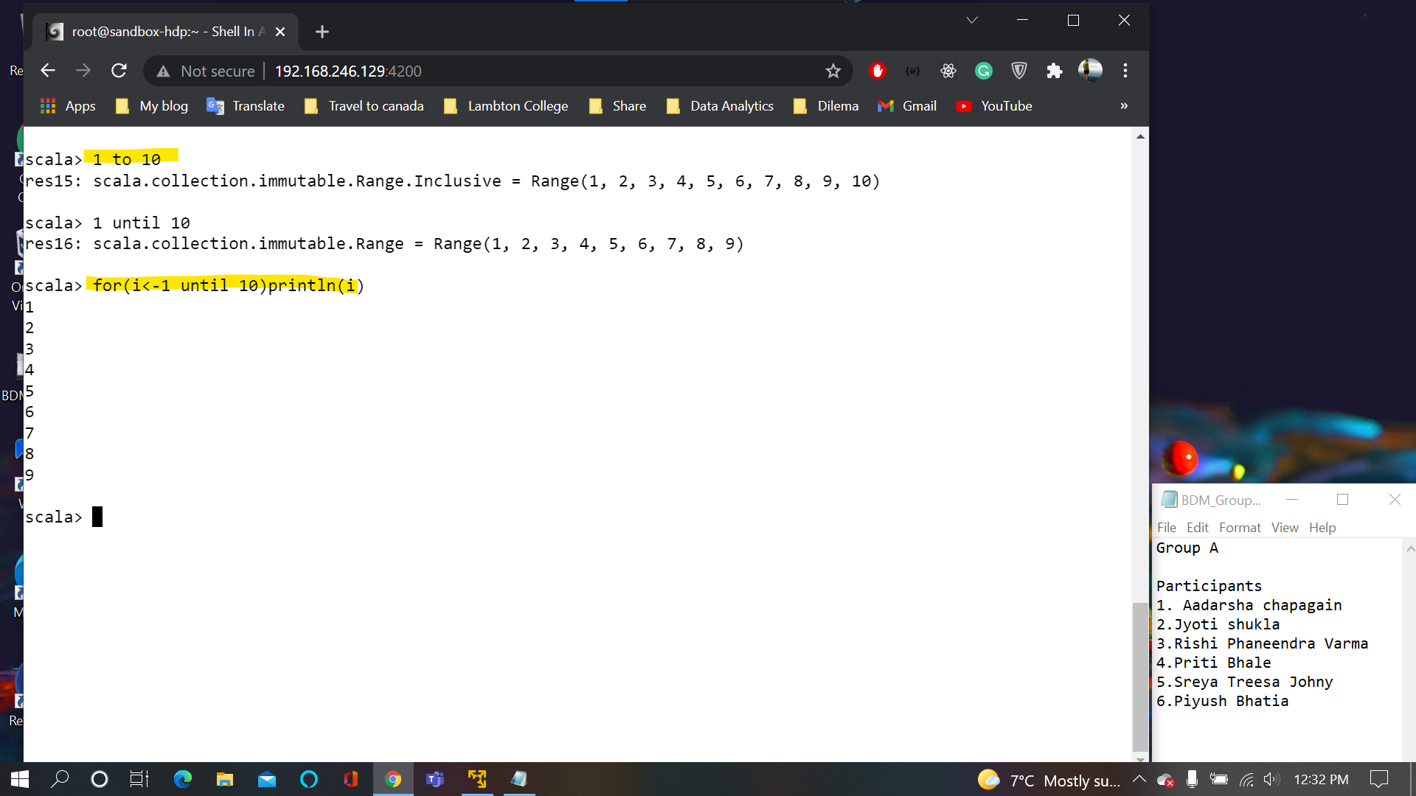

**Slide 39:**

for(ch<- 0 until x.length)println(x(ch))

for (ch <- x)println(ch)

It takes each character from x which is the string and assign it to “ch” variable then ch become a character variable (of type character)

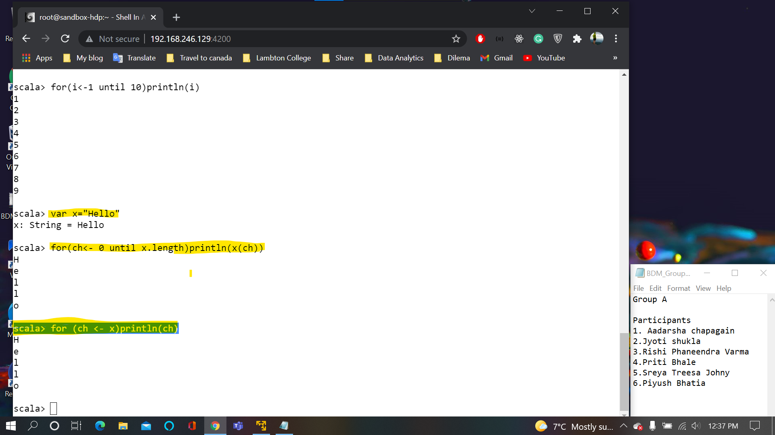

**Slide 41:**

for(i<-1 to 5){

for(j<-1 to 2){

println(i*j)

}

}

scala> for(i<-1 to 5;j<- 1 to 2) println(i*j)

Advance looping in scala rather than traditional approach

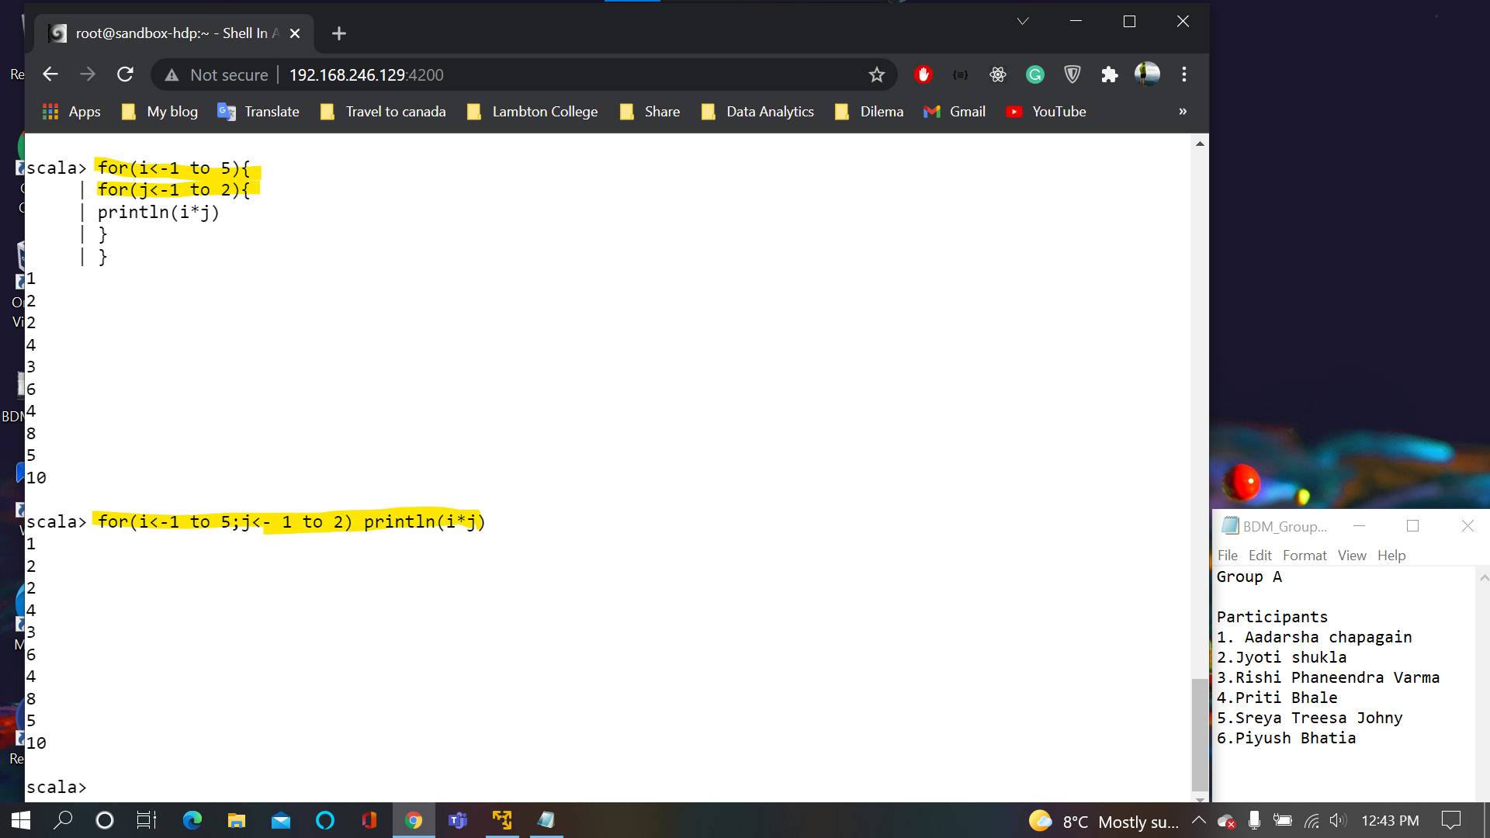

**Slide 42:**

for(i<-1 to 5;j<-1 to 2;product=i*j)println(product)

for(i<-1 to 5;j<-1 to 2;product=i*j)println("Percentage: " + (product/2.5))

Within println we can concatenate two expression to form one single expression

Dynamic value is product/2.5

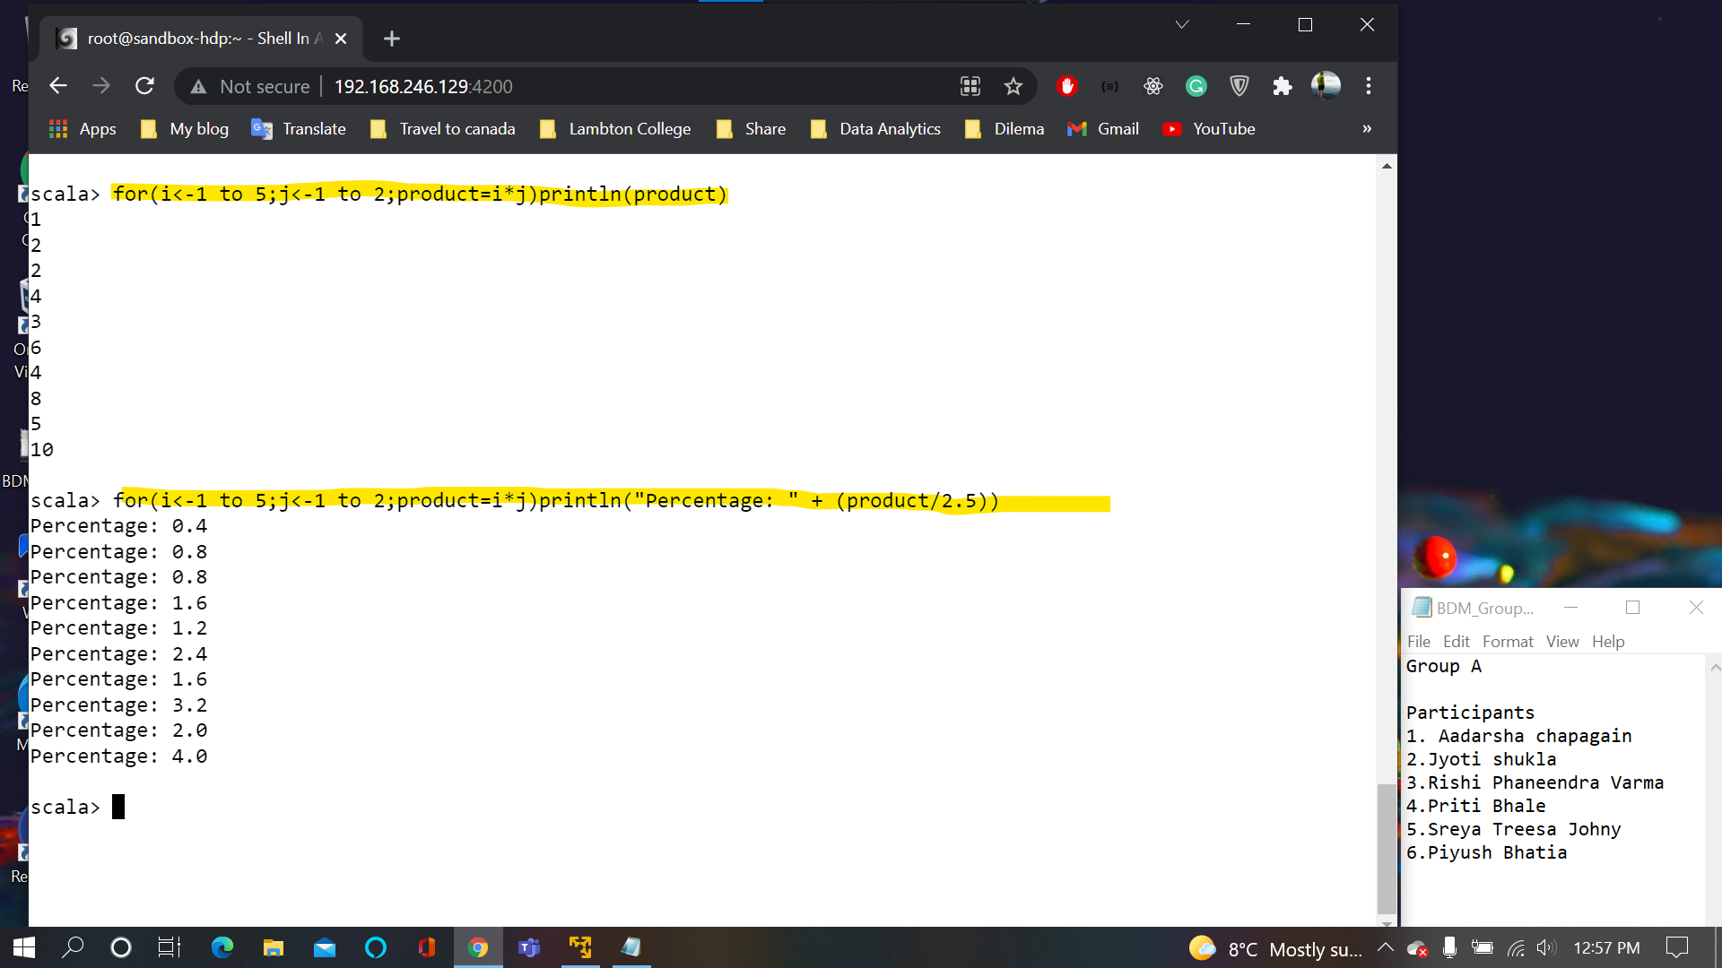

**Slide 43:**

Guard is a condition which is applied in For

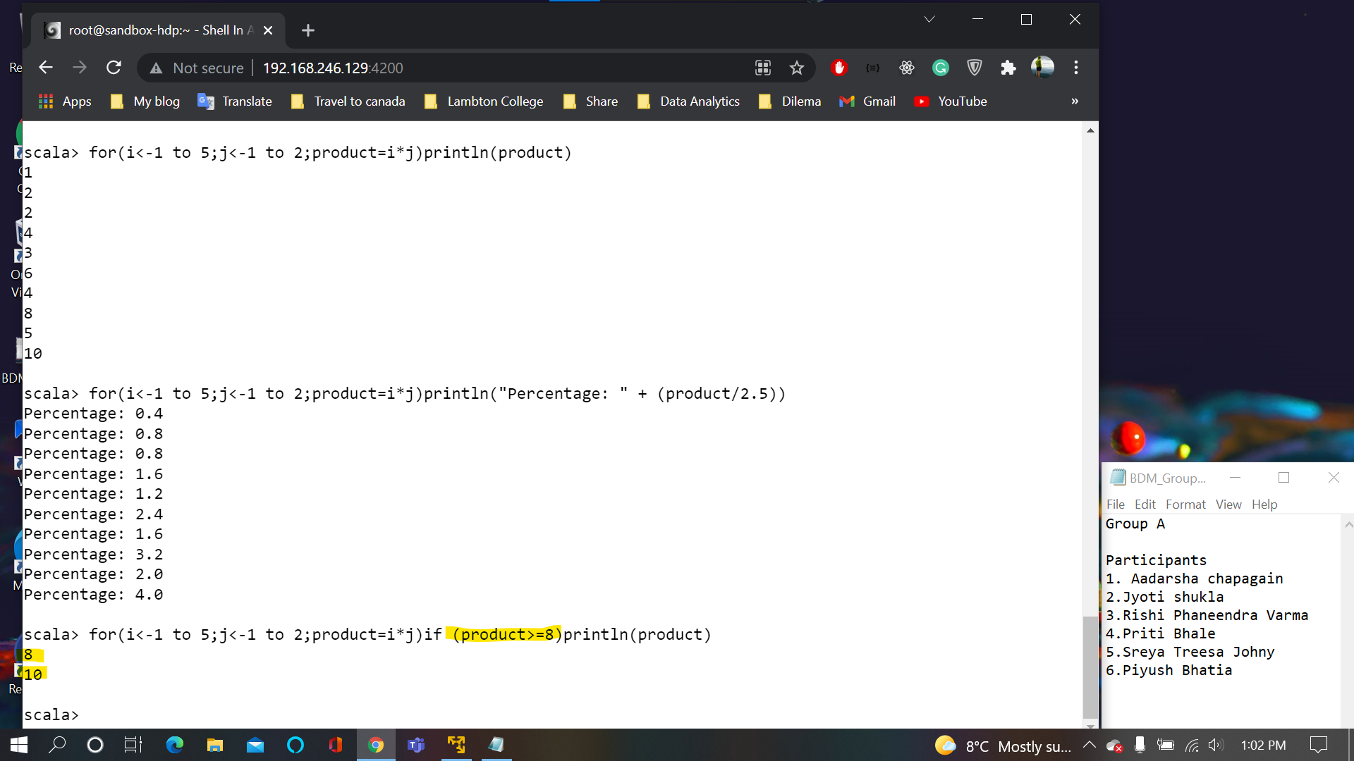

**Slide 45:**

Yield is used for compression. If we want to do something on individual value for loop is used and if we want all the individual values to be combined **yield** is used

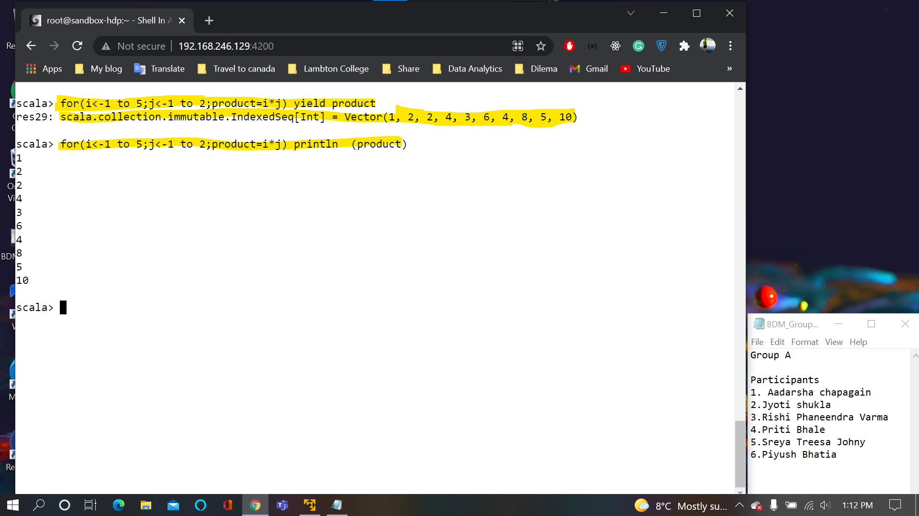

**Slide 46:**

**ASCCI Value**

**The first one will print ASCCI value of every character in Hello**

**The Second one will print ASCII + value given by I from the loop**

**For H it will go like 72+1(i=1), 72+2(i=2) and so on for every character.**

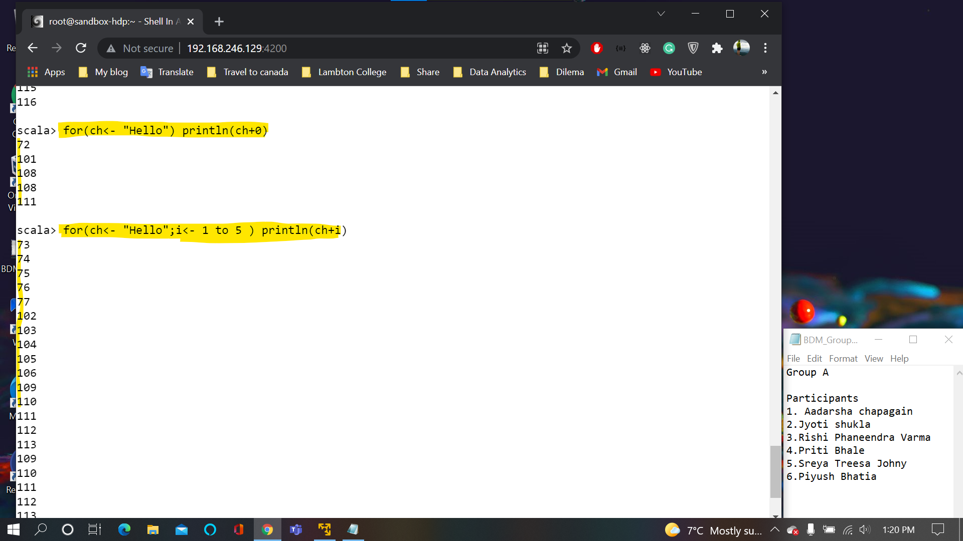

**Slide 47:**

**If the expression of yield has two different types than the output of the yield will have the datatype of first generator that is i integer here**

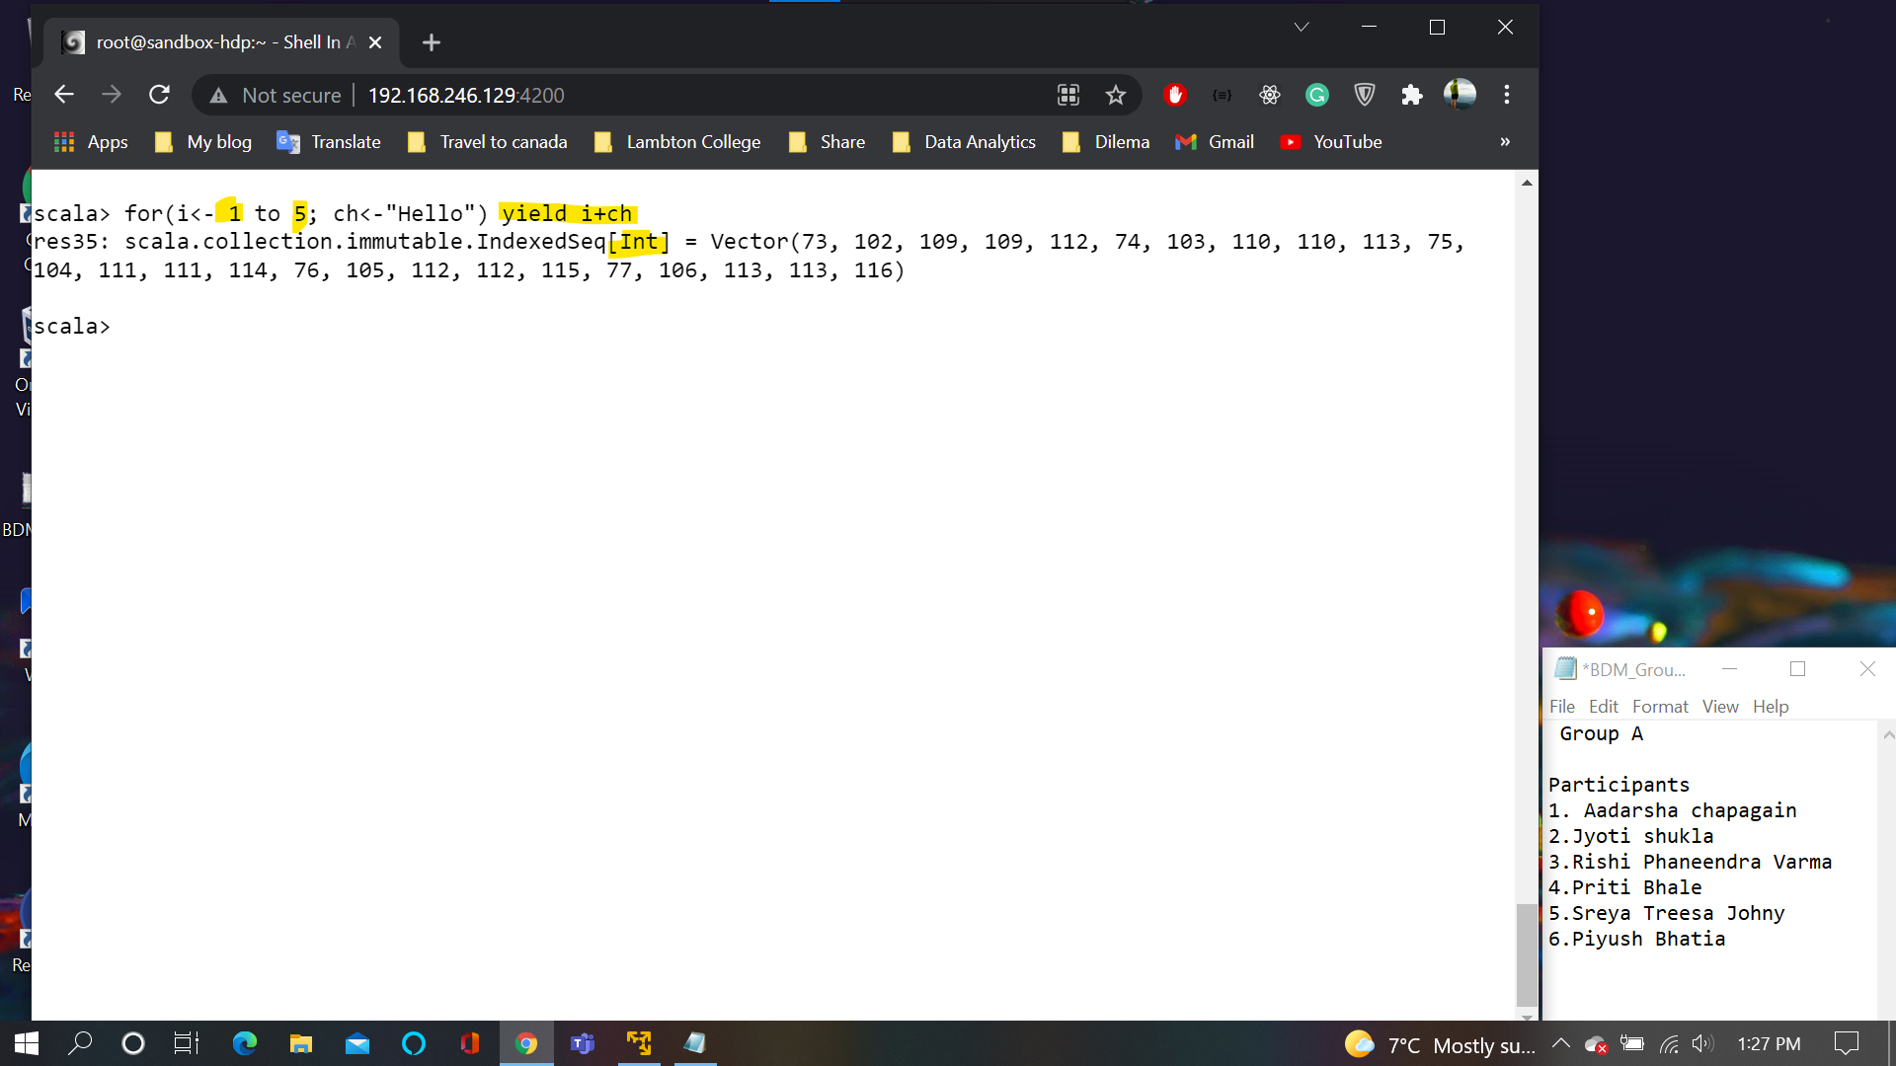

**Slide 53:**

**Function in scala**

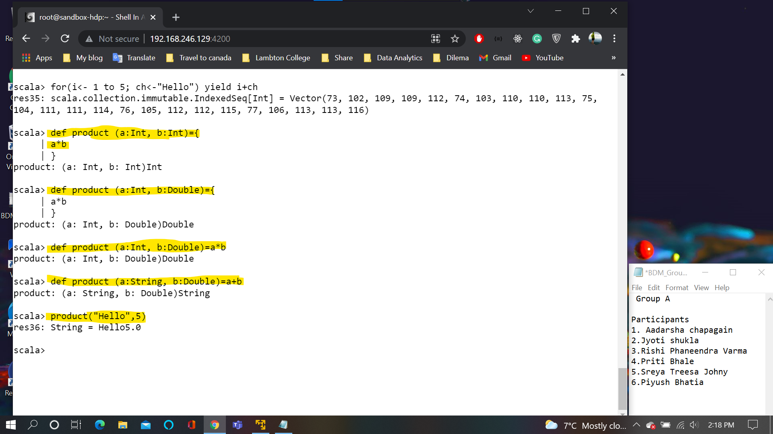

**Slide 54:**

Multiple Line function

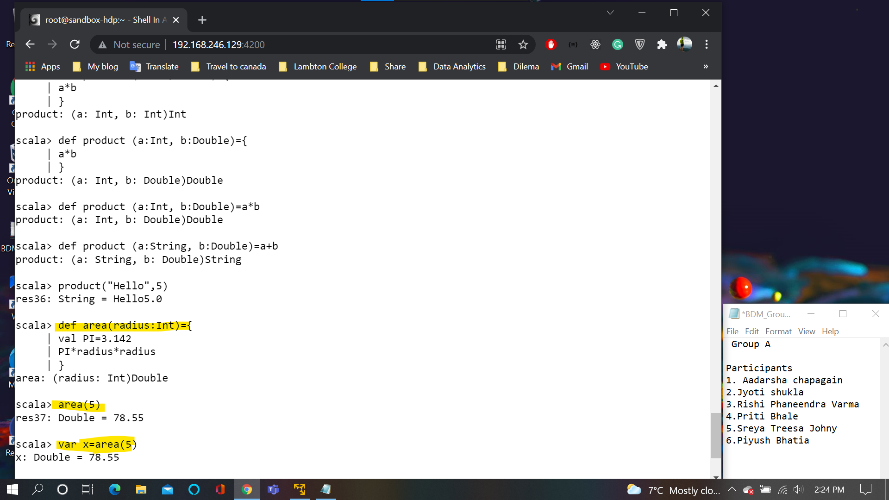

**Slide 56:**

A procedure is a function that does not return value

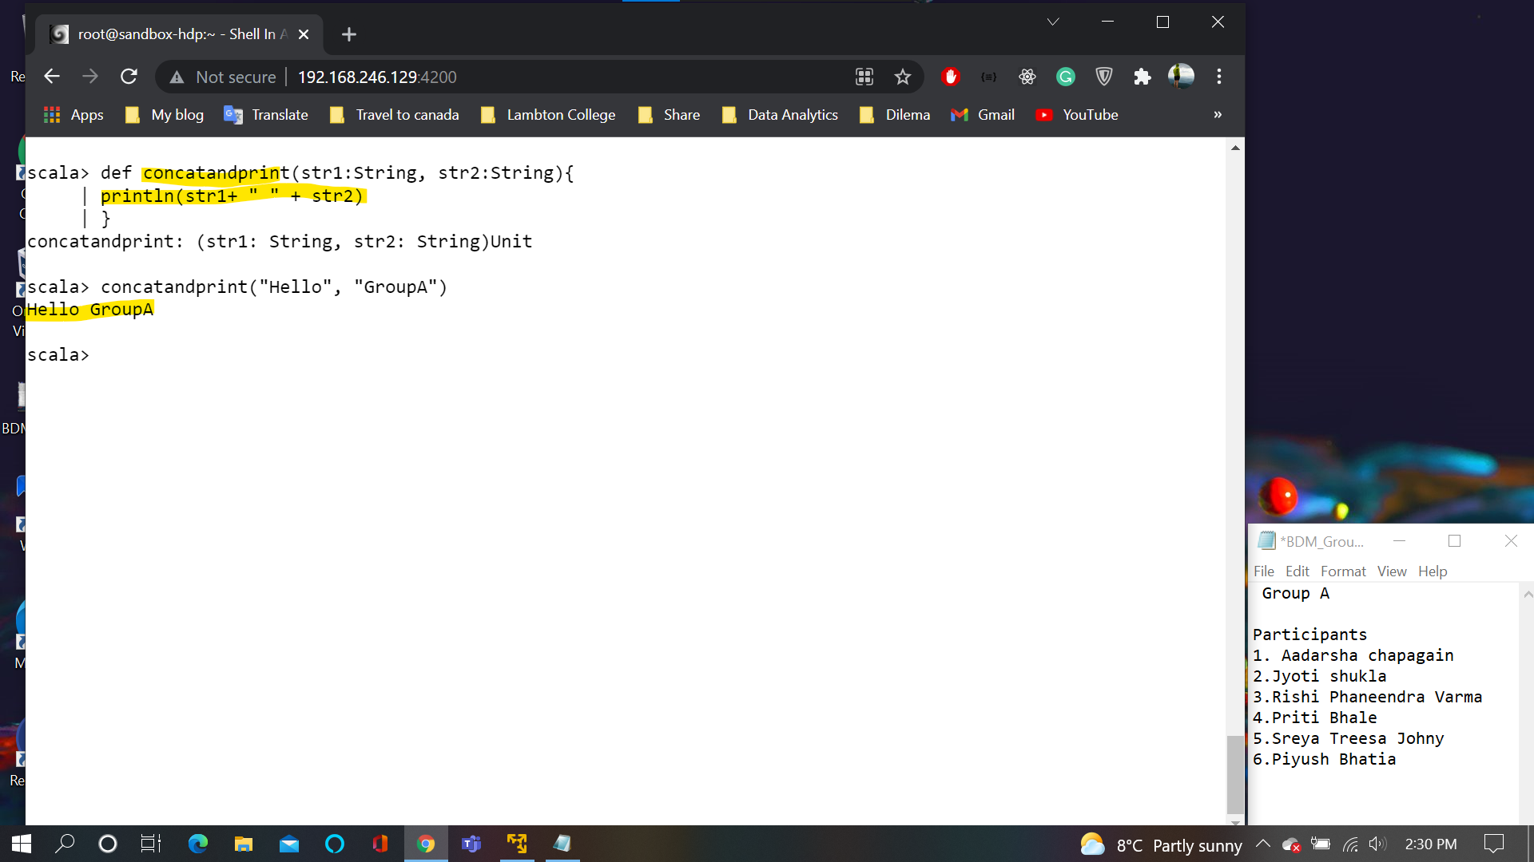

**Slide 58:**

Default argument

The mandatory argument should be in front of default arguments.

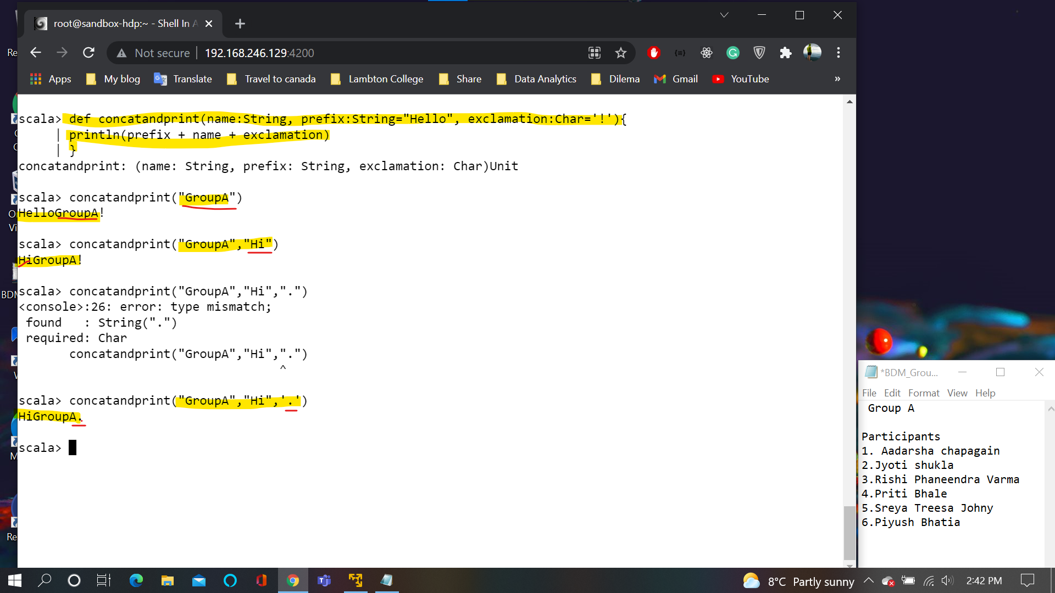

**Slide 59:**

The order and the name of the argument must match in the slide 58 both were matched but they are not matched here so order of argument must match

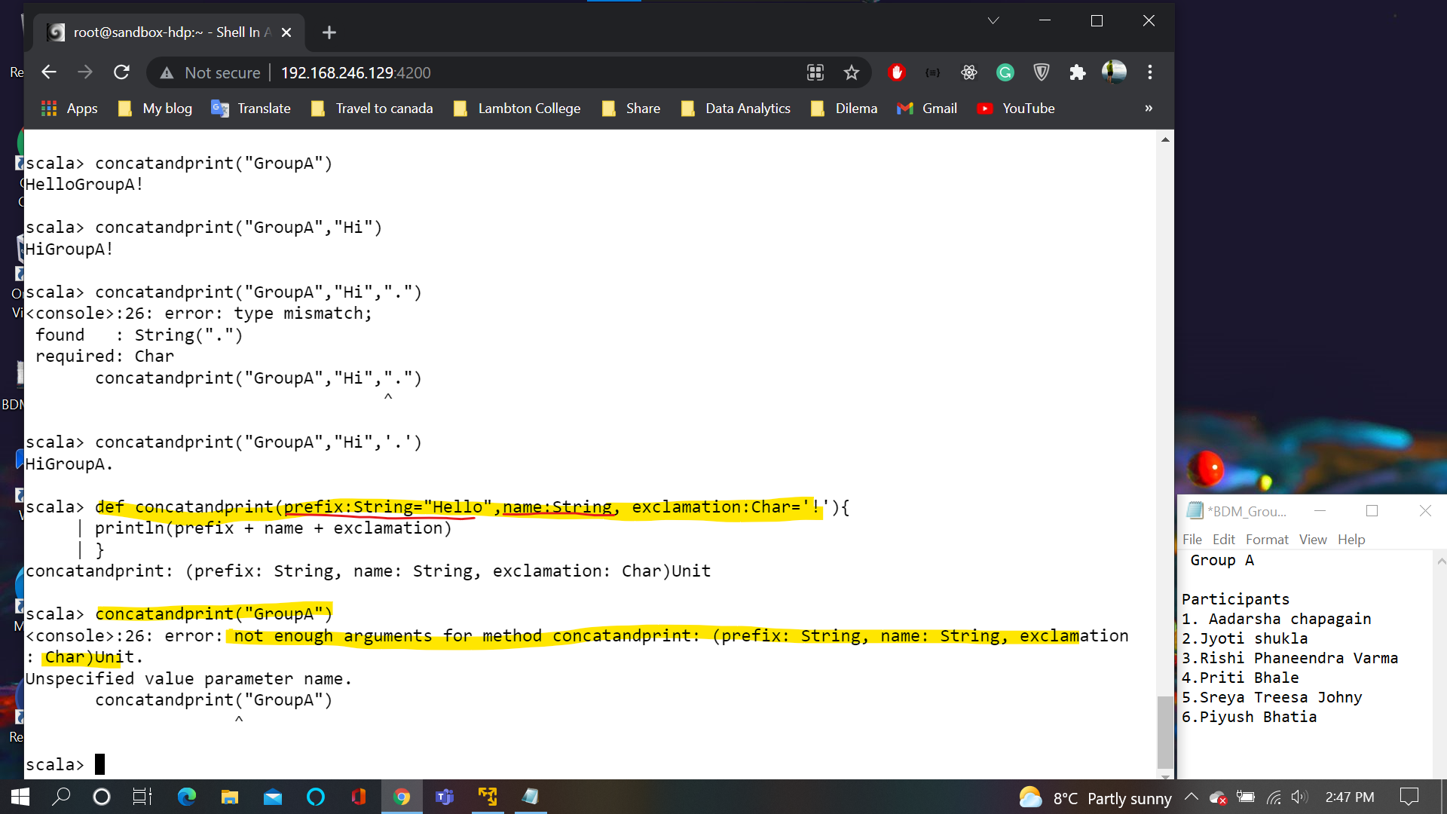

**Slide 60:**

In case of named argument order is not important

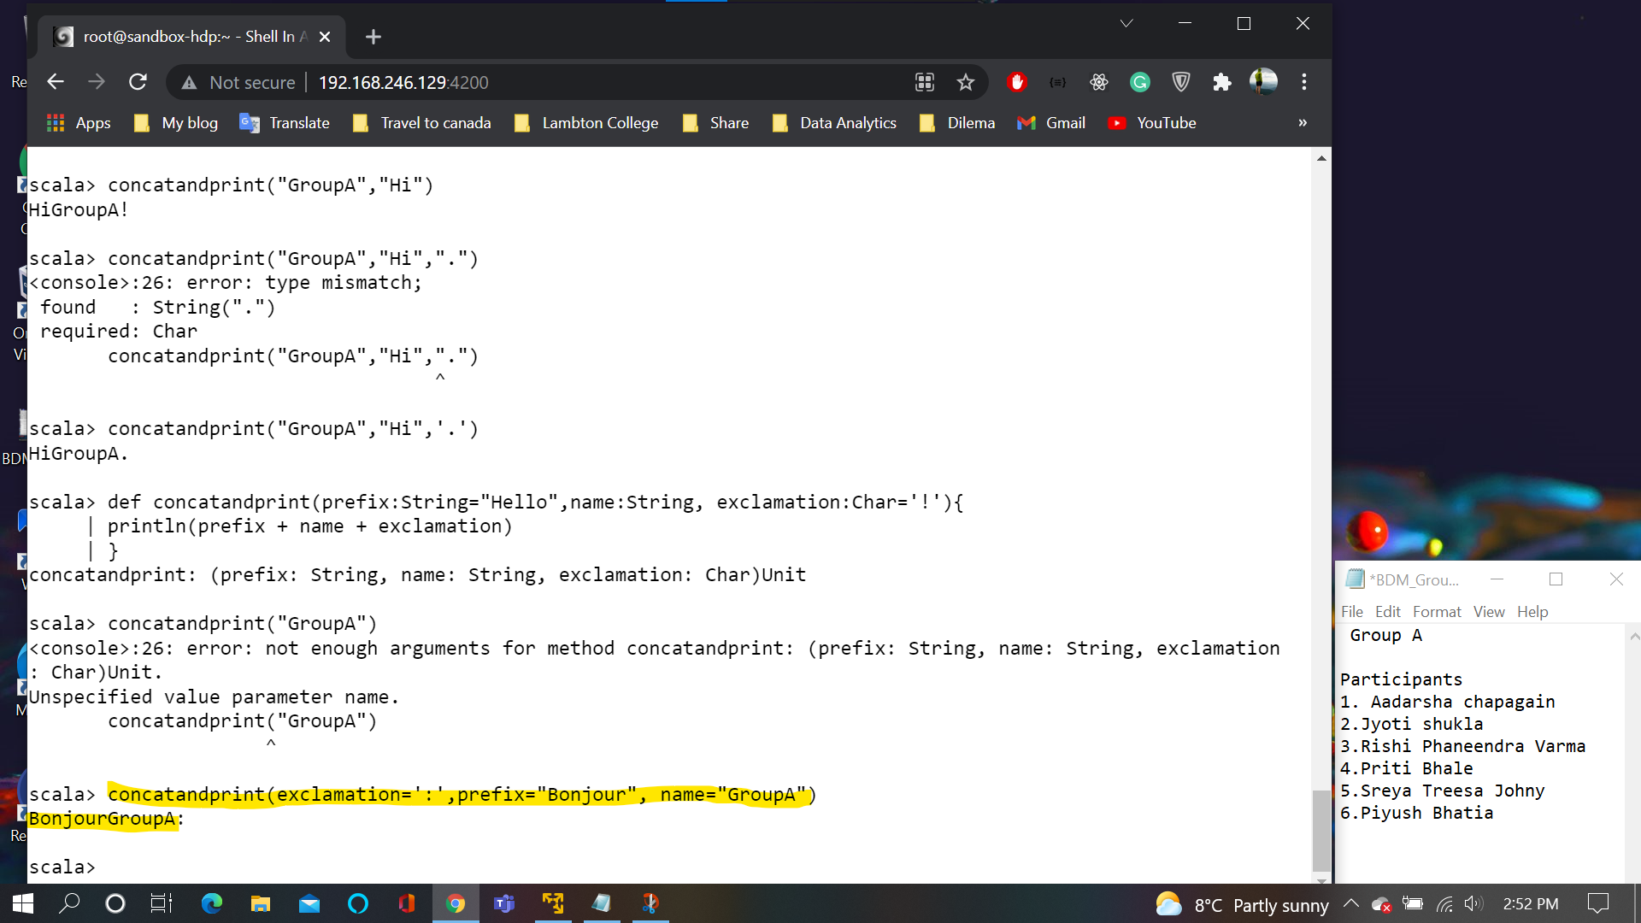

**Slide62:**

The function expects sequence as arguments

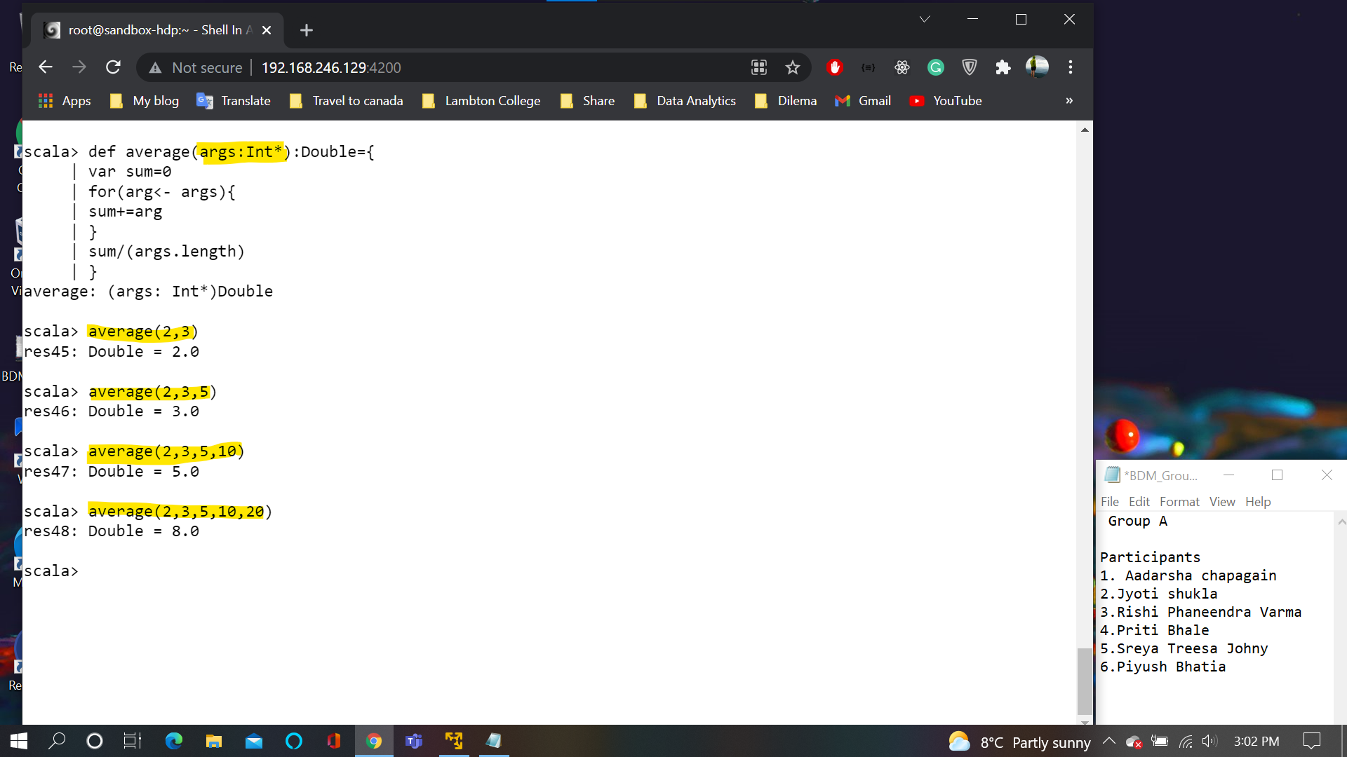

**Slide64:**

Internally, Scala arrays are converted into a Java array of the corresponding type

Array is a class

Default data type for inter is 0, double is 0.0 and string is null.

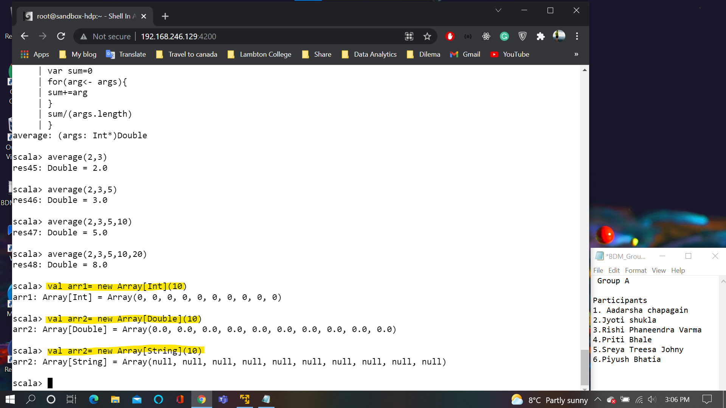

**Slide65:**

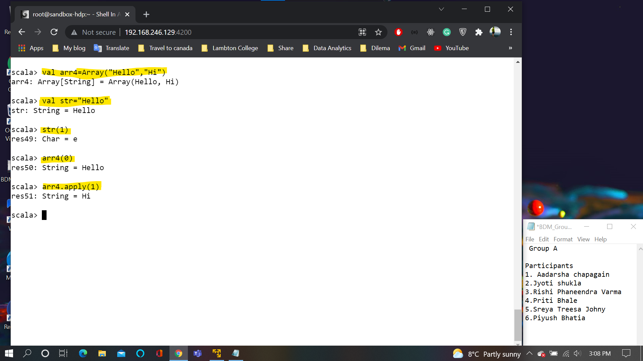

**Slide67:**

The ArrayBuffer Data type should be imported from scala.collection.mutable

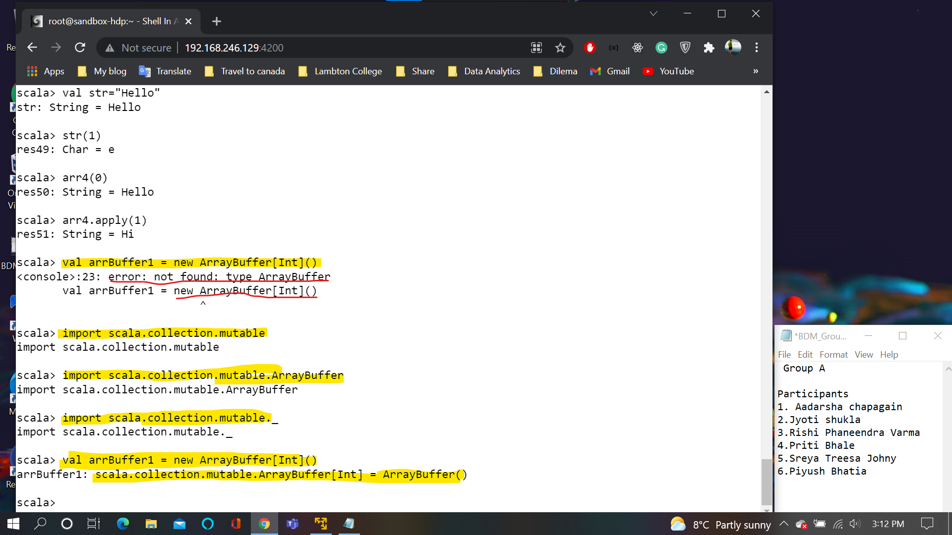

**Slide68:**

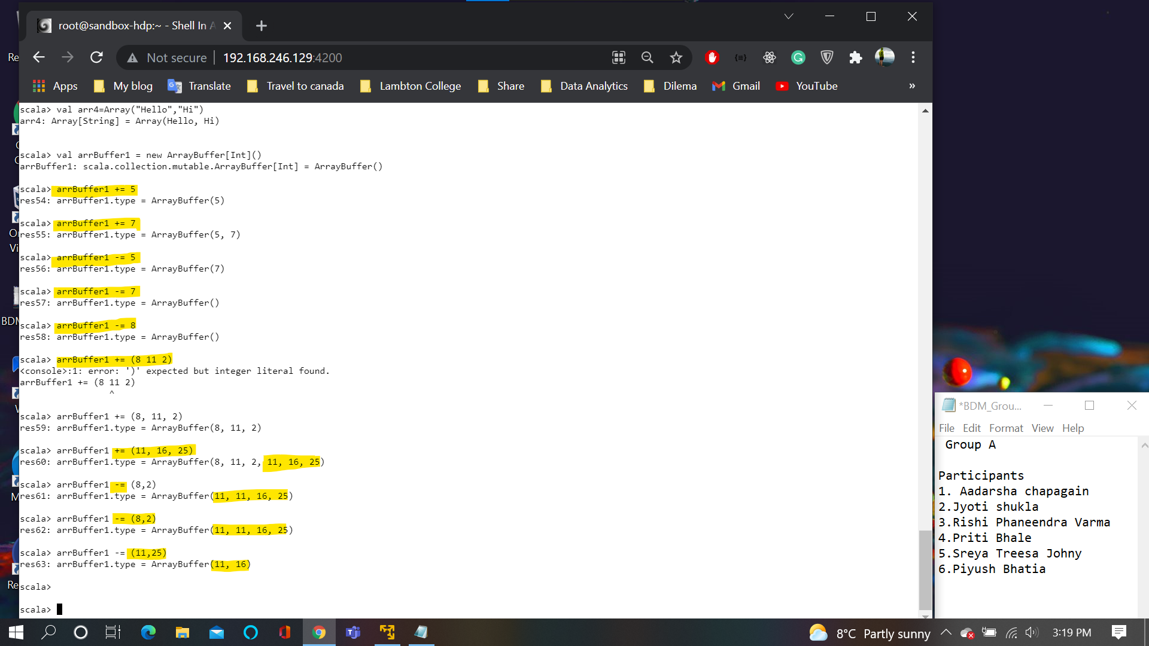

**Slide69:**

Operations on slide (addition and removal)

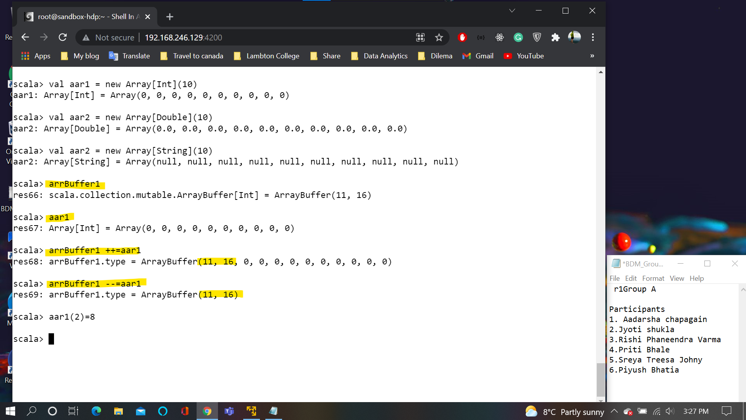

**Slide71:**

Different operation on array

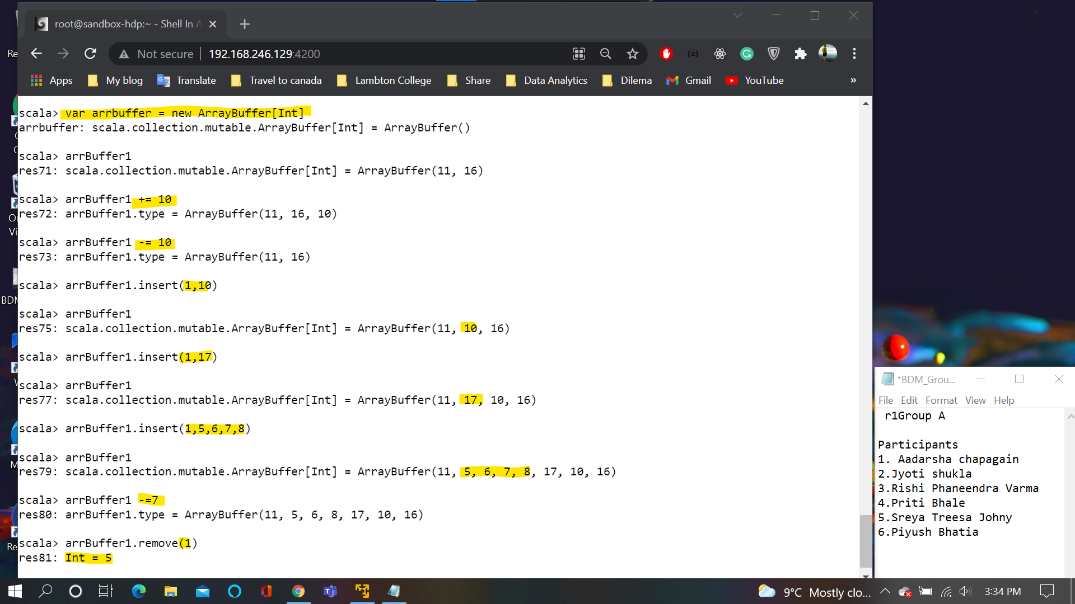

**Slide74:**

More Operations on Array

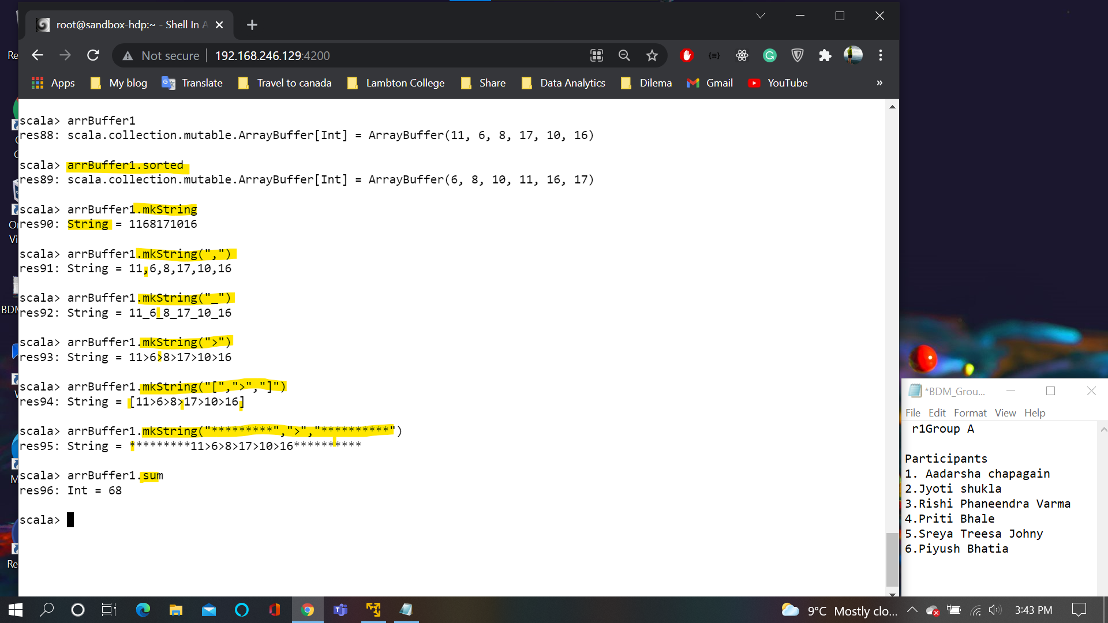

**Slide76:**

On clicking tab all the available function wil be displayed

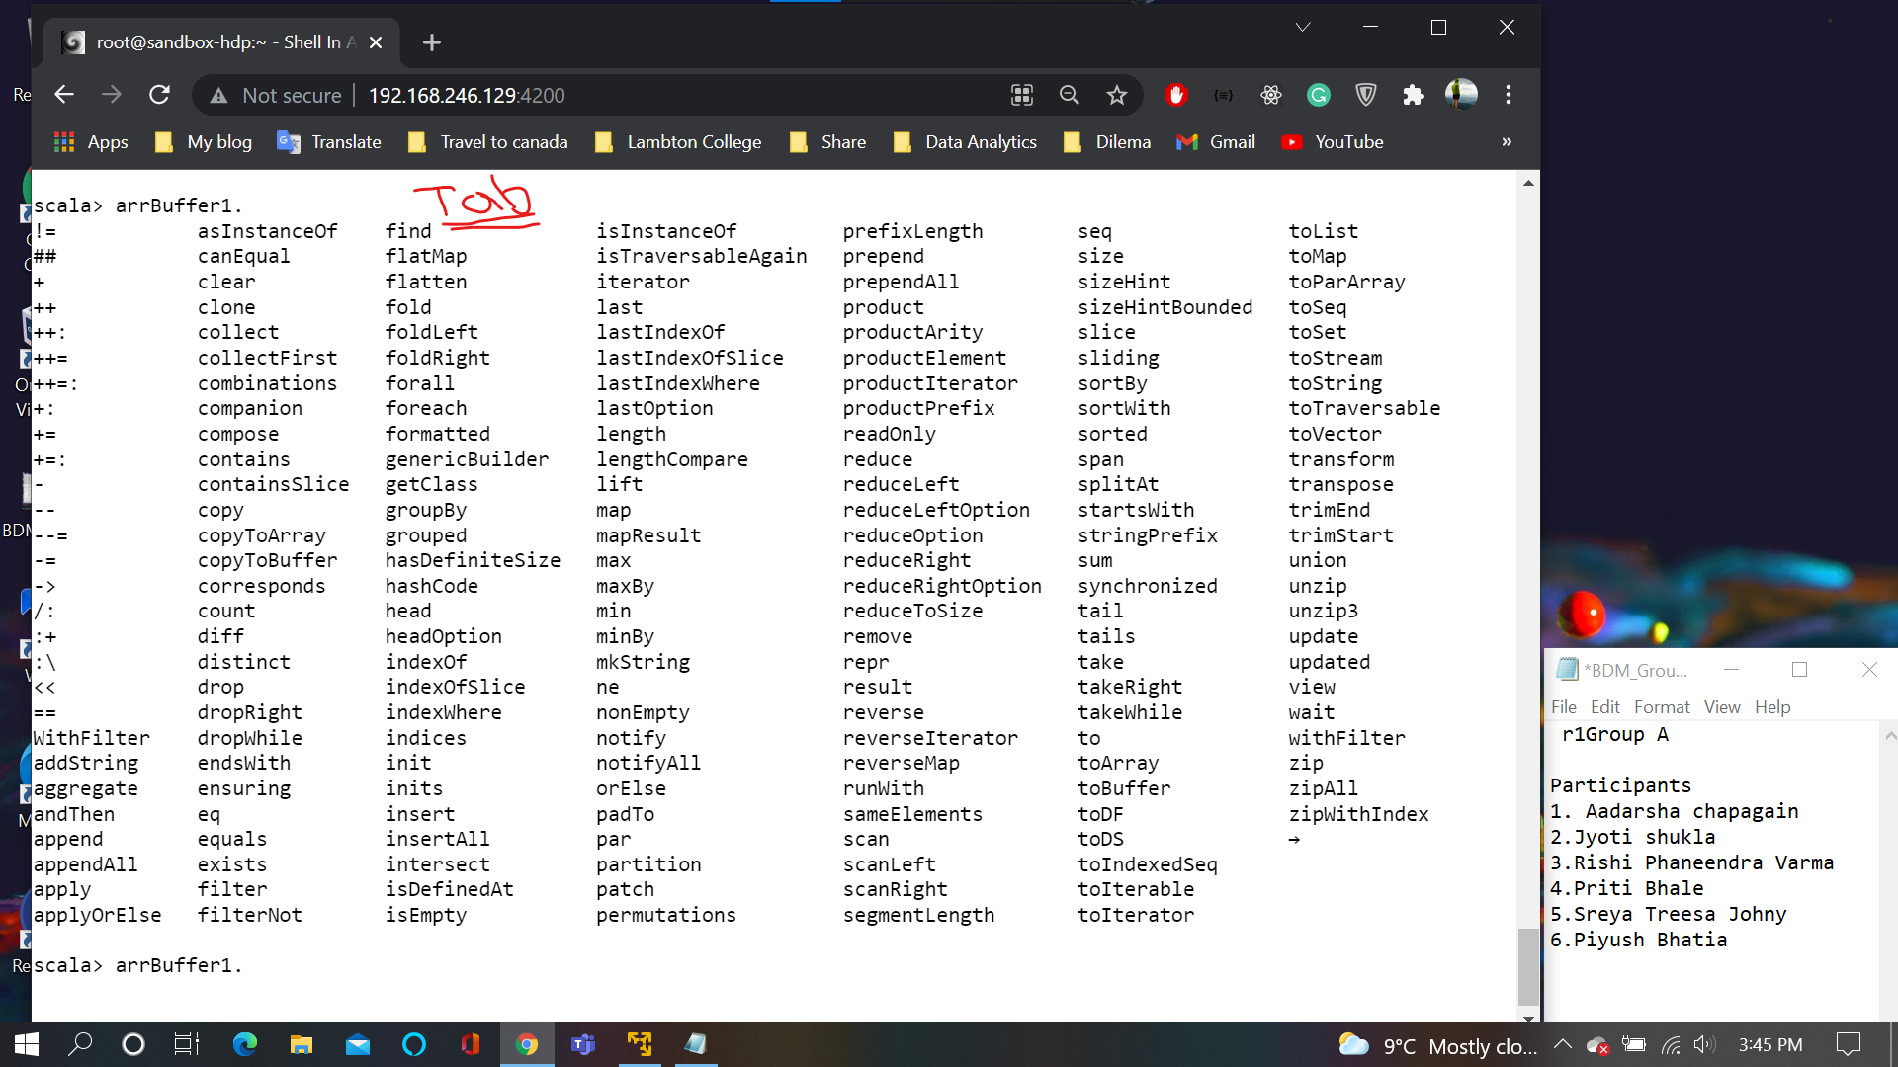

**Slide78:**

Fixed and variable length Array

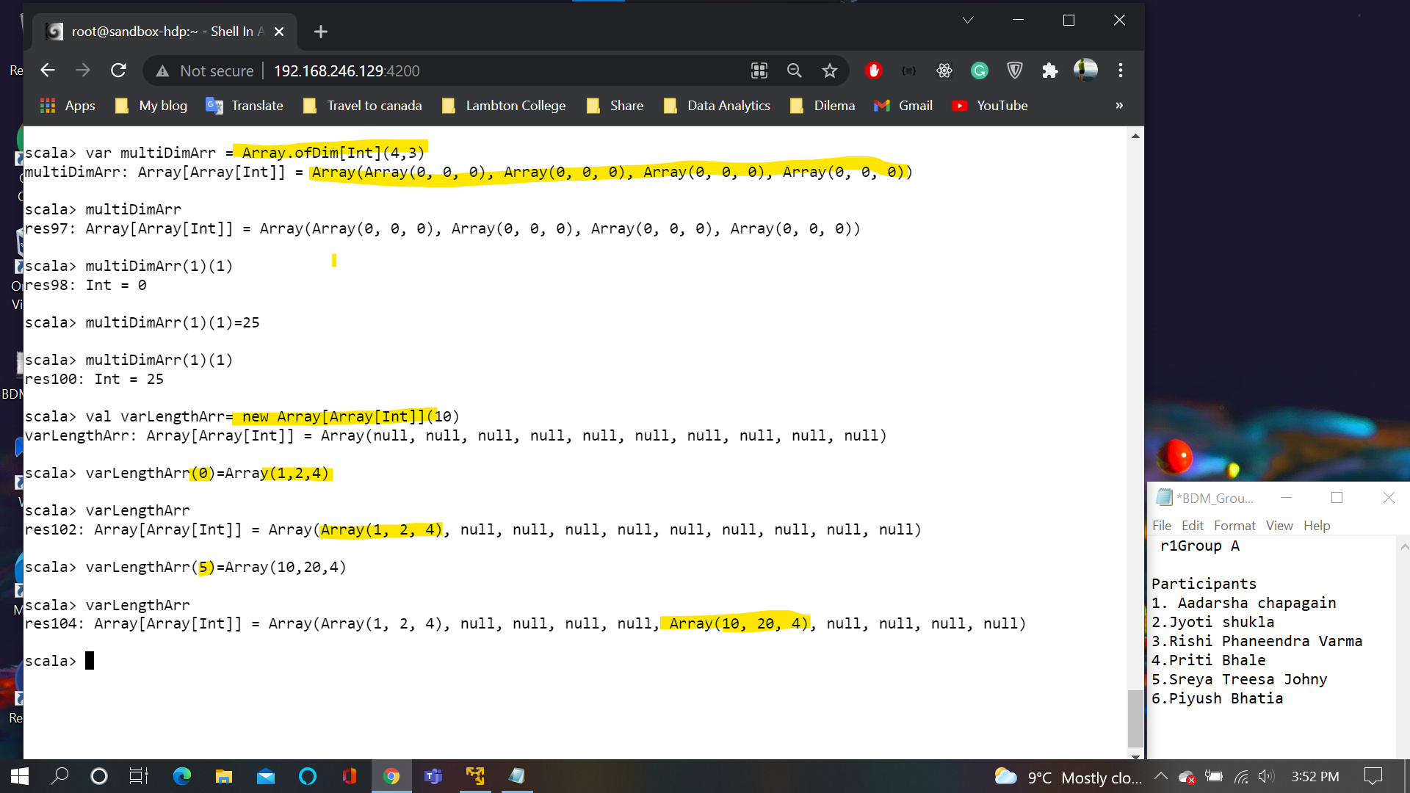

**Slide80:**

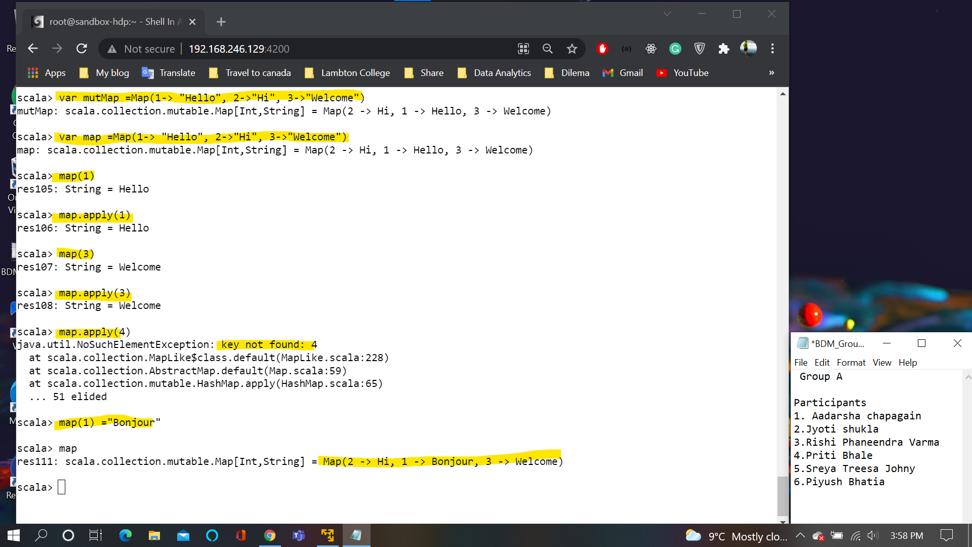

**Slide81:**

mapOrElseget:**If the value is present get the value else get the specified default value**

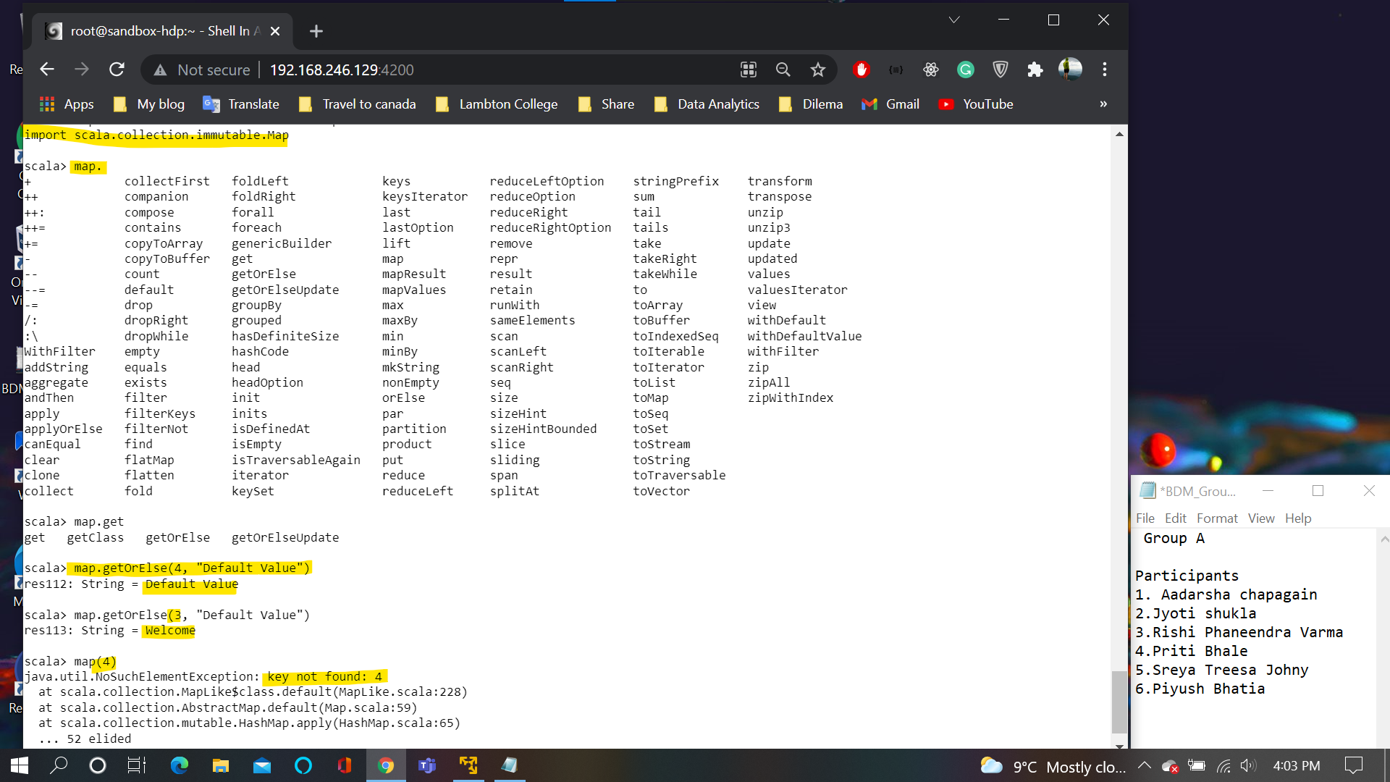

**Slide82:**

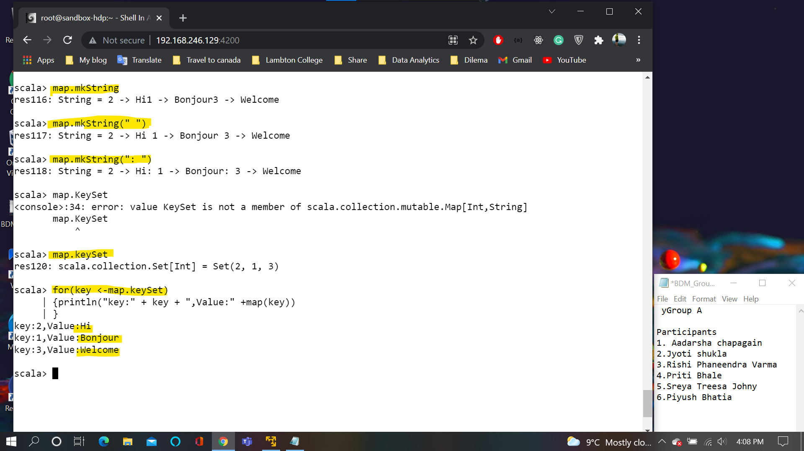

**Slide84:**

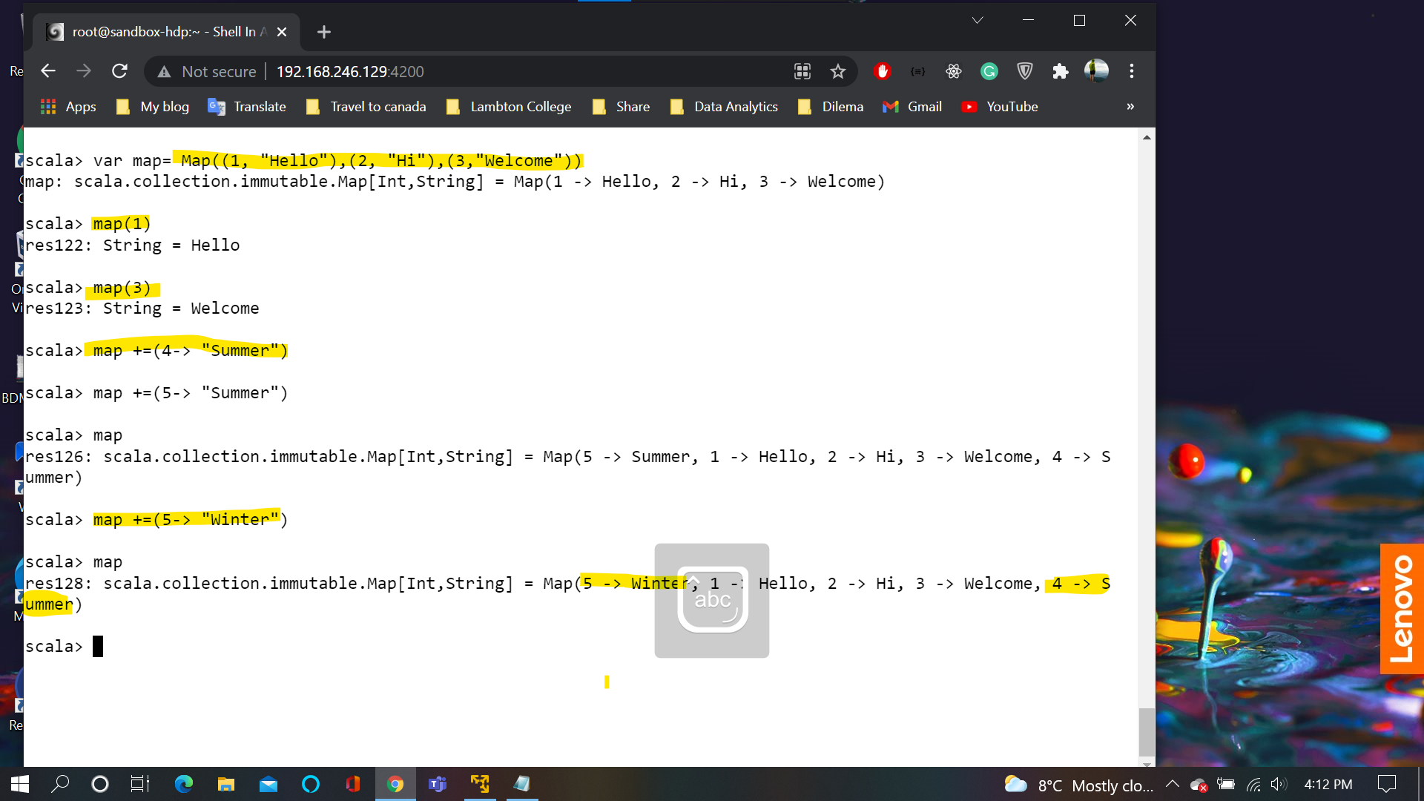

**Slide85:**

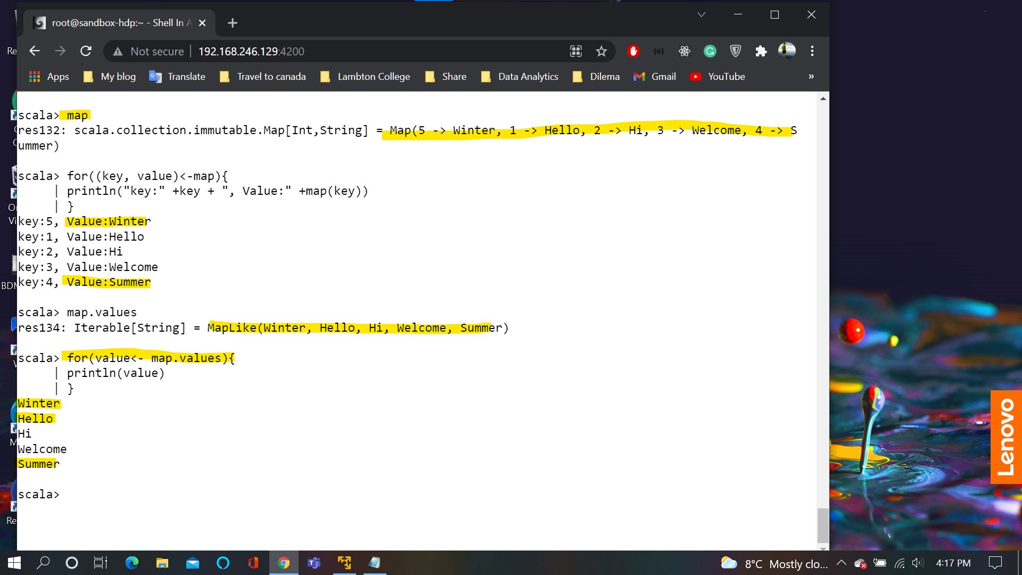

**Slide87:**

The map entries would be sorted based on key

LinkedHashMap will create a map that will retain the insertion order of element

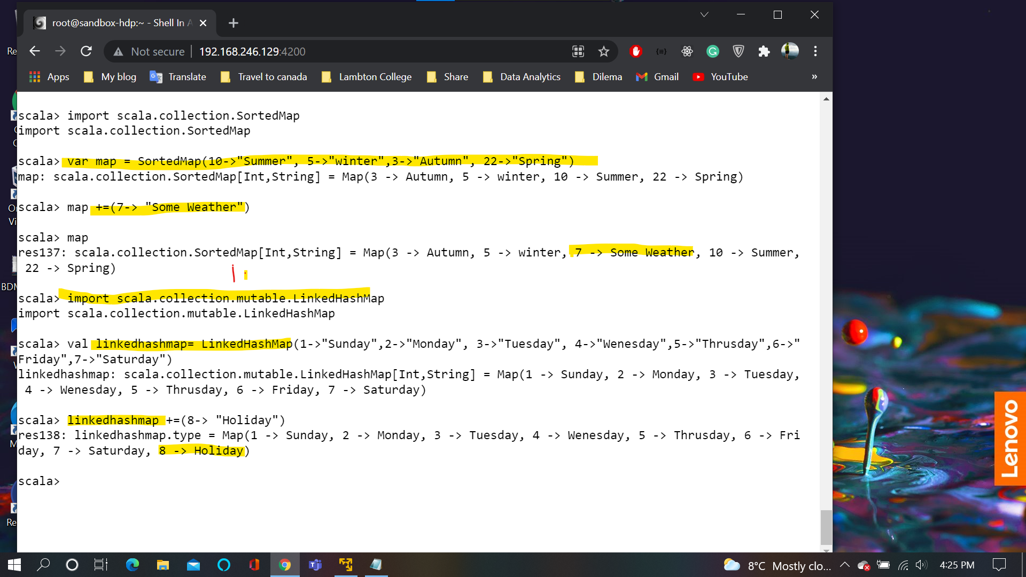

**Slide88:**

Tuples are group of value that can be of disparate type

